**Mobile APP**

The main goal of the application is making bridge between a essential goods provider and a customer. The application should act as communication tool between the customer and owner of the store. As per my understanding I will make a plan to build the application in the next few steps.

Technology stack which I would like to implement in this project

Unlike other e commerce app here we have two different end users

1. Customer
2. Owner

For this we need to develop two interfaces where customer can add his products and check his availability of stock. He can manually delete a product from the store if it comes out of the stock.

In this project we need to maintain same database for customer and owner. When customer performs some operations like adding a product, deleting a product or updating the price of the product etc. The changes should appear in the user end also.

In the future we will add a feature when the owner adds his product to the application, he can add the availability of the stock in store. So, when customer buys a product then automatically the stock goes down and it should notify the owner when it is out of stock. And we will discuss more about other features we are going to implement in the owner module.

First let’s begin with owner module.

**Customer:**

Let’s visualize and design some user interfaces from the customer end

We need to maintain a table for customer in the database, when ever customer validates his data, User should land in the landing page i.e Home page. Where user can see some daily essential goods on the home page.

If customer wants to register as a new one then he will click on the register link then he will be routed to registration form. Where he can add his name and create his user id and password for the login. We need to push this form data into the customer table.

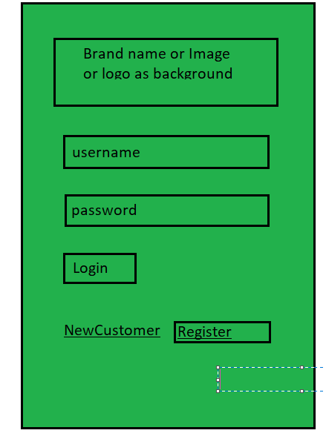

When customer is already registered and we can enable OTP login also through mobile. One missing link here is “Forgot password” .

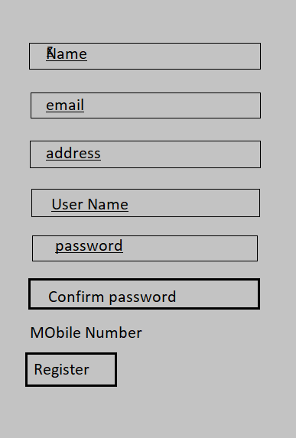

When User enter his login info and he lands on main page,

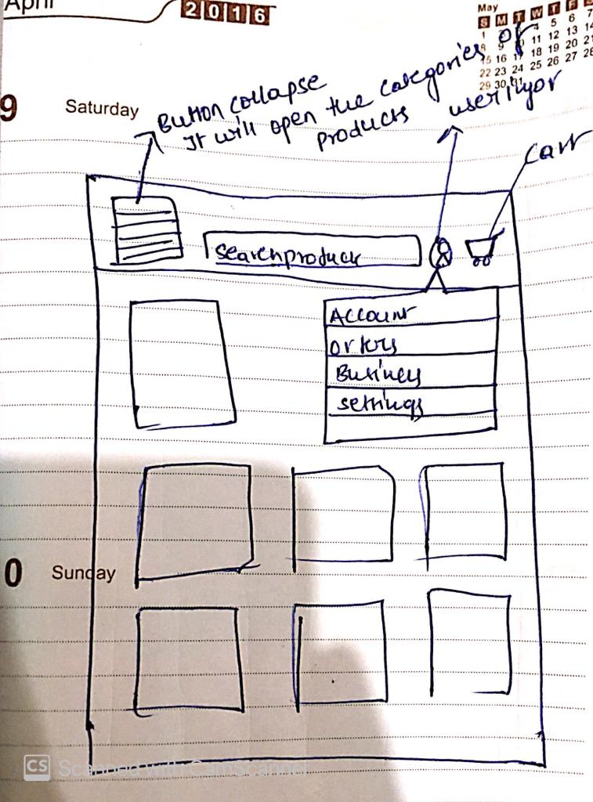

When user click on the collapse button on the left most side he can see the category of products

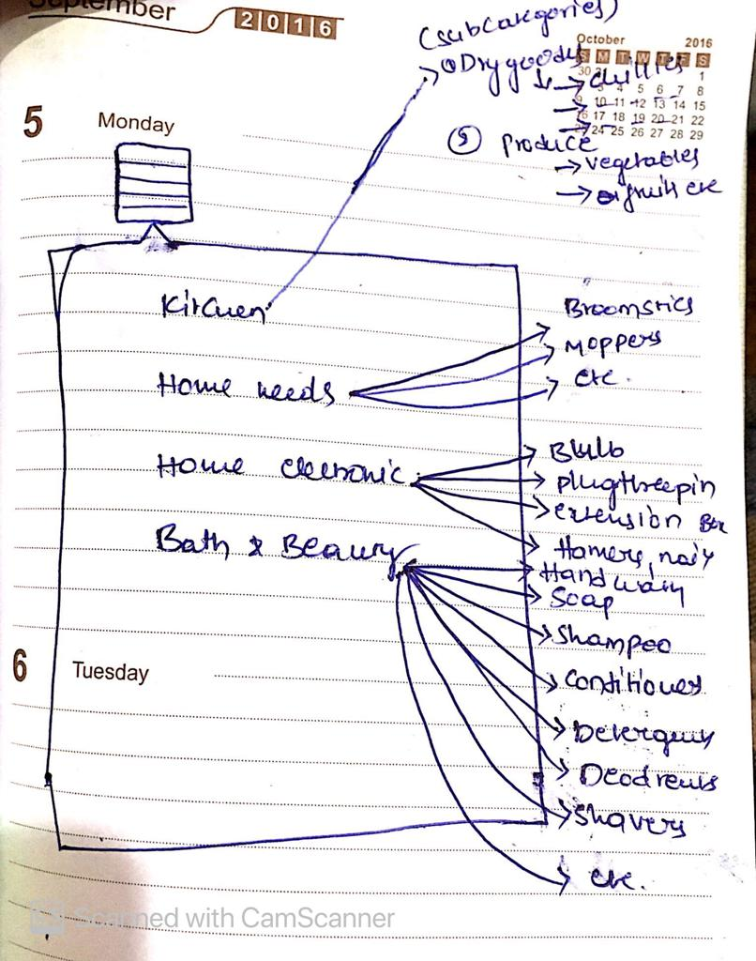

Every category item is assigned with a link. When user clicks on the specific product it should display on the body of the page .

The product should be displayed like this way.

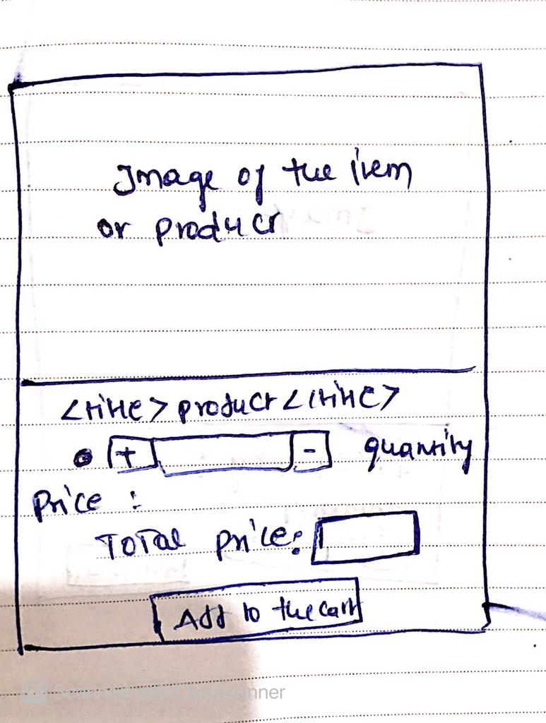

When we push the item in the cart, we can edit the quantity of item there also. And we can see the total price of the items. Here customer can select

1.cash on delivery,

2.Store Pickup,

3.payment.

* Cash on delivery will push a notification to the owner by placing the order in owner instance, We can alert the owner by msg or an email.